COMPUTER PERIPHERAL DEVICES

❖ Types of Printers, Scanners, and Webcams

➤ TYPES OF PRINTERS, SCANNERS, AND WEBCAMS WITH THEIR REAL-LIFE USES
DEVICE | TYPE | REAL-LIFE USE CASE
Printer | Inkjet Printer | Used for printing college assignments, project reports, and color photographs.
Printer | Laser Printer | Used in offices for fast printing of reports, bills, and business documents.
Printer | Dot Matrix Printer | Used in banks, stores, and warehouses for printing invoices and multi-copy receipts.
Scanner | Flatbed Scanner | Used for scanning certificates, photographs, and important documents into digital form.
Scanner | Handheld Scanner | Used in supermarkets and warehouses for scanning barcodes and small documents.
Webcam | Built-in Webcam | Used for online classes, video meetings, and virtual interviews.
Webcam | External USB Webcam | Used for live streaming, content creation, and high-quality video conferencing.

- CONCLUSION:
Printers, scanners, and webcams are essential computer peripheral devices that make everyday tasks easier and more efficient. Printers create hard copies of documents, scanners convert paper documents into digital files, and webcams enable video communication. These devices are commonly used in educational institutions, offices, businesses, and homes, making them an important part of modern computing

- CONNECTION OF A HOME PRINTER TO A LAPTOP/PC

- LABELLED DIAGRAM

- USB Connection

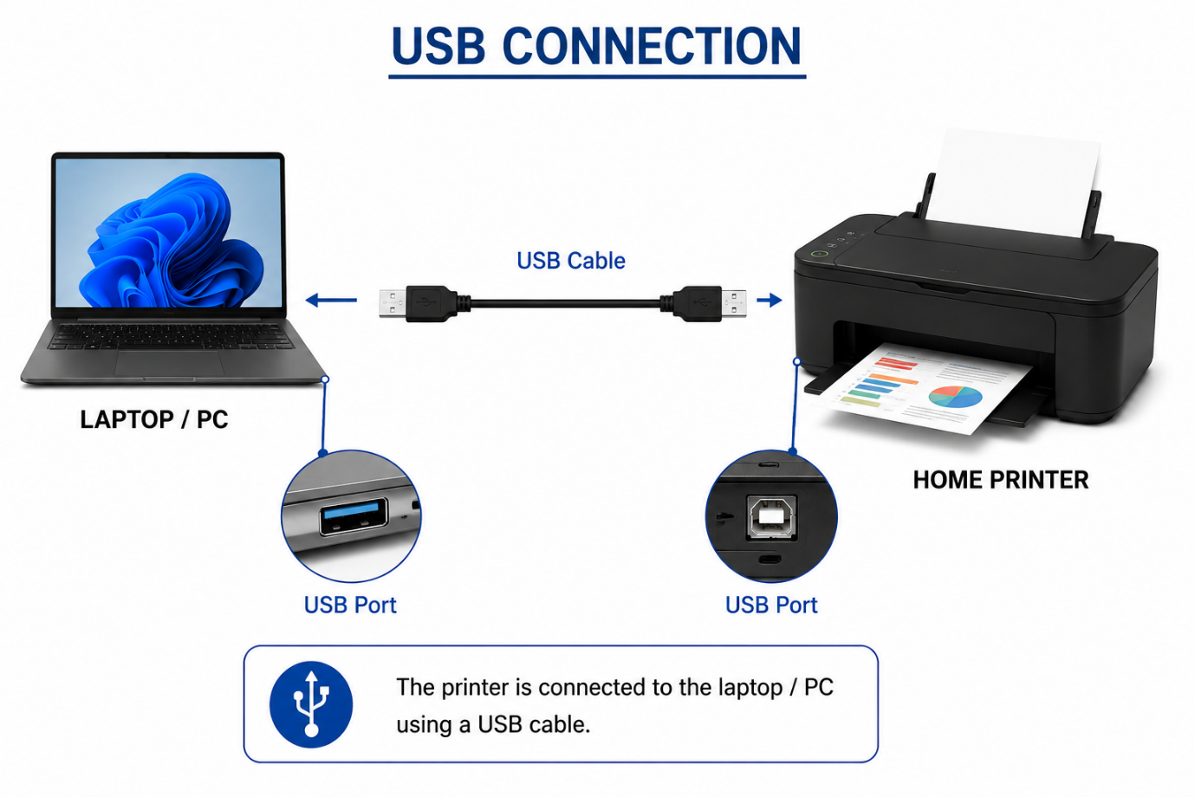

- Wi-Fi Connection

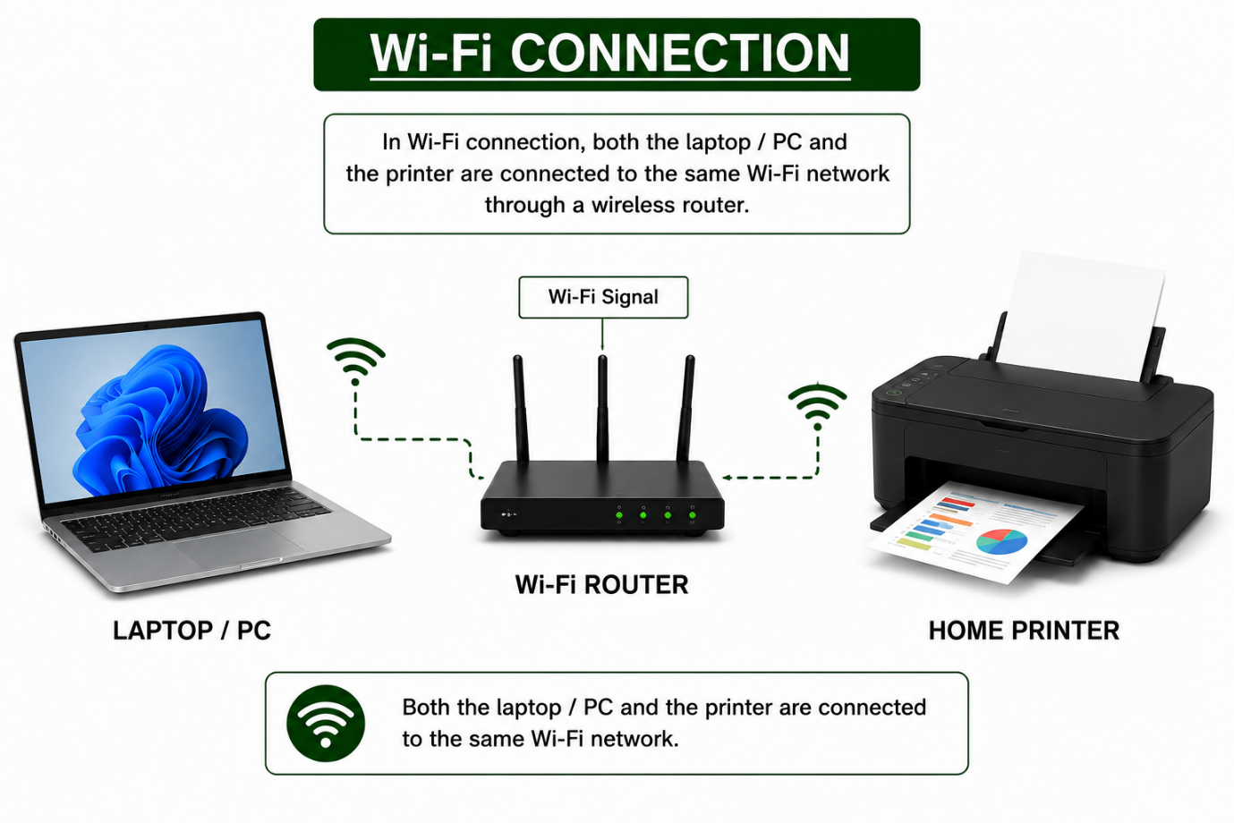
- Bluetooth Connection

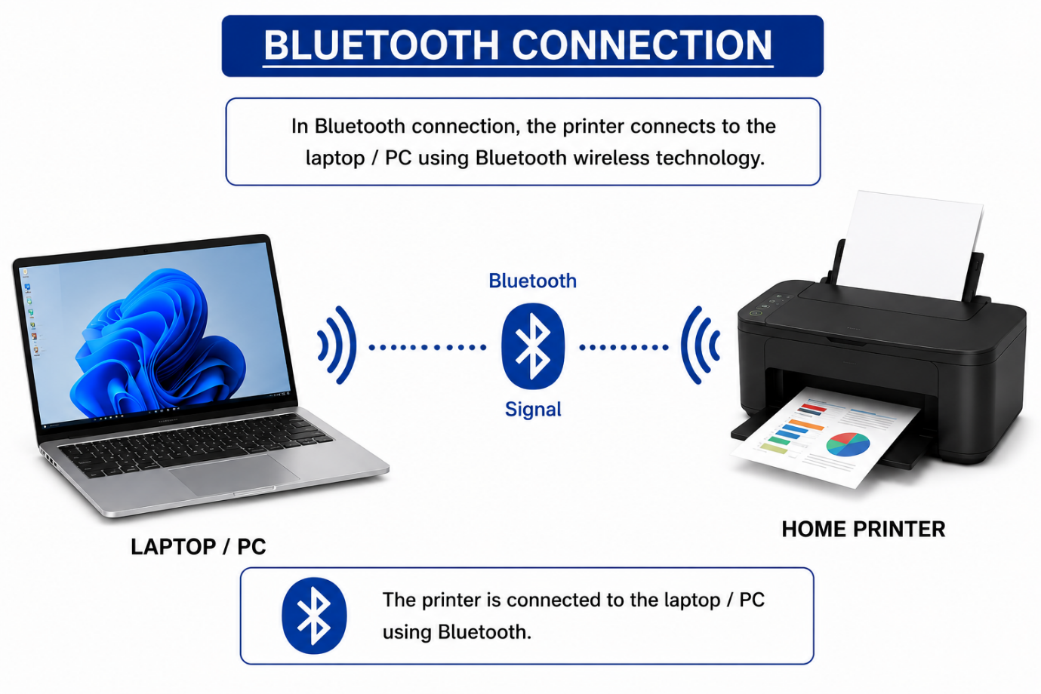

- Connection Interfaces Used by Computer Peripherals

- Connection Interfaces with Their Advantages and Disadvantages

Connection Interface | Peripheral Examples | Advantage | Disadvantage
USB (Universal Serial Bus) | Printer, Scanner, Webcam | High-speed data transfer, reliable connection, and compatible with most computers. | Requires a cable, limiting mobility and connection distance.
Wi-Fi | Printer, Scanner | Wireless connection allows convenient printing and scanning from multiple devices on the same network. | Depends on Wi-Fi signal strength and network availability; setup may be more complex.
Bluetooth | Printer, Webcam | Convenient wireless connection, easy to pair, and low power consumption. | Slower data transfer, short operating range, and limited compatibility with some older devices.

- Speed → High-speed (USB), slower (Bluetooth)
- Convenience → Wireless, easy to use (Wi-Fi/Bluetooth)
- Compatibility → Compatible with most computers (USB), limited compatibility for some Bluetooth devices

- Connecting a USB Printer to a Computer

➤ Introduction
A USB printer is one of the most commonly used output devices at home, schools, colleges, and offices. It is connected to a computer using a USB cable, which provides a fast and reliable connection. After connecting the printer, the required drivers are installed so that the computer can communicate with the printer.
➤ Step-by-Step Instructions
Step 1: Place the printer near the computer and connect it to a power source.
Step 2: Turn on the printer by pressing the Power button.
Step 3: Connect one end of the USB cable to the printer and the other end to a USB port on the computer.

Step 4: Wait for the computer to detect the printer automatically.
Step 5: If the printer driver is not installed automatically, install it using the CD provided with the printer or download the latest driver from the printer manufacturer's official website.
Step 6: Open Settings → Bluetooth & devices → Printers & scanners (Windows), click Add device, and select the printer if required.
Step 7: Print a test page to confirm that the printer is connected and working correctly.

➤ Conclusion
A USB printer can be connected quickly and easily using a USB cable. Once the printer driver is installed and the printer is detected by the computer, it is ready to print documents, assignments, and photographs efficiently.

